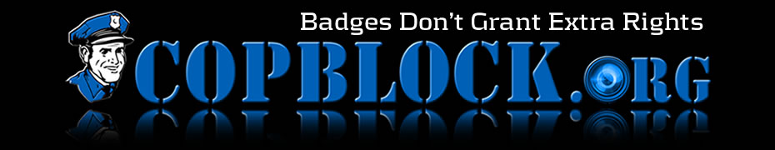
FOR IMMEDIATE RELEASE September 13, 2011
Chalk The Police – You Can Be Heard
National Chalk the Police Day – Saturday, October 1, 2011
In the wake of the June 4th arrests outside the Manchester New Hampshire Police Department, October 1st will mark “National Chalk the Police Day” with peaceful activism in a town near you.
On June 4th, 2011, a pro-police accountability rally was held outside the Manchester Police Department to draw attention to the dubious killing of resident James Breton and clearing of officers who savagely beat Christopher Micklovich. At the rally, activists voiced their concerns by using children’s sidewalk chalk as a medium. These actions resulted in the unjust arrest of eight people and the seizure of nine cameras and phones. Charges included graffiti, criminal mischief, disorderly conduct and resisting arrest.
Regarding this event CopBlock.org believes that those wearing badges didn’t like their authority being questioned and reacted by using the only tool they know: force. There was no victim or damage to property in the offenses alleged. The arrests, charges and pending court dates are nothing more than harassment intended to chill dissent.
Chalk the Police is a nation wide campaign to raise public awareness about policing issues. On October 1, folks from all over the country will be heading out to their local police station(s) or parks (anywhere that’s public property) to advocate, in solidarity, police accountability.

Activists are encouraged to carry signs, pass out informational fliers and write sidewalk messages to voice their messages of protest. Local and independent Media is encouraged to cover these peaceful events. Current cities that are participating include:
Keene, NH – 2:30pm Sat, Oct 1st Manchester, NH – 1pm Sat, Oct 1st
Bellevue, OH – 4pm Sat, Oct 1st Columbus, OH, – 12pm (noon), Oct 1st
Minneapolis, MN – 1pm Sat, Oct 1st San Diego, CA – 1pm Sat, Oct 1st
San Jose, CA – 10am Oct 1st ALL of California – Oct 1st
Phoenix, AZ – 10am Sat Oct 1st Quartzsite, AZ – 1pm Sat Oct 1st Philadelphia, PA - 2pm Oct 1st Kansas City, MO – 2pm Oct 1st
Las Vegas, NV (UNLV) – 10am Oct 1st Durango, CO – 1pm Oct 1st
Lake Worth, FL – 11am Oct 1st
Contact: Ademo Freeman - (262) 305-9206 - ademo@copblock.org
For information about National Chalk the Police Day and CopBlock: http://www.copblock.org/CHALKTHEPOLICE/
Informational YouTube video: http://youtu.be/UF1O1XOjkCA
# # #

